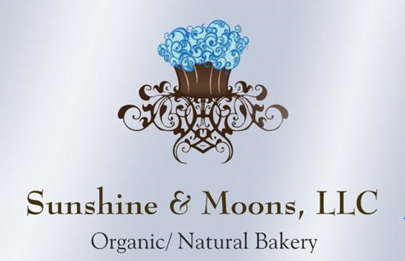

**Pie Menu**

**Organic Pie Options**

Regular Pumpkin & Apple Pies $30

GF Pumpkin & GF Apple Pies $32 Regular Cherry, Blueberry, Mixed Berry Crumble, Peach Brandy Pies $32

GF Cherry, Blueberry, Mixed Berry Crumble or Peach Brandy Pies $34

Regular Pecan Pie, Lemon Blueberry & Strawberry Rhubarb Pies $32

GF Pecan Pie, Lemon Blueberry & Strawberry Rhubarb Pies $34

Key Lime, Chocolate Silk, Banana Cream, or Coconut Cream Pies $32

GF Key Lime, Chocolate Silk, Banana Cream or Coconut Cream Pies $34

Lemon Meringue $34

GF Lemon Meringue $36

**Note: Some pies are seasonal upon availability of Local Organic Ingredients**

**Organic Quiche**

**Quiches $29.00/Each GF Quiches $31/Each**

Spinach Mushroom Quiche, Spinach Bacon Quiche, Quiche Lorraine (Bacon/Onion)

**Savory Organic Pie Options (Take n Bake)**

Savory Rosemary Chicken Pies w/ Herb Double Crust **$34/Each**

GF Savory Rosemary Chicken Pies w/ Herb Double Crust **$37/Each**

**Place your Special Order Today!**

***Gift Baskets Available ***Chocolate Boxes Available****Gift Certificates Available***

***Ask about Gluten Free, Vegan & low Sugar Options***